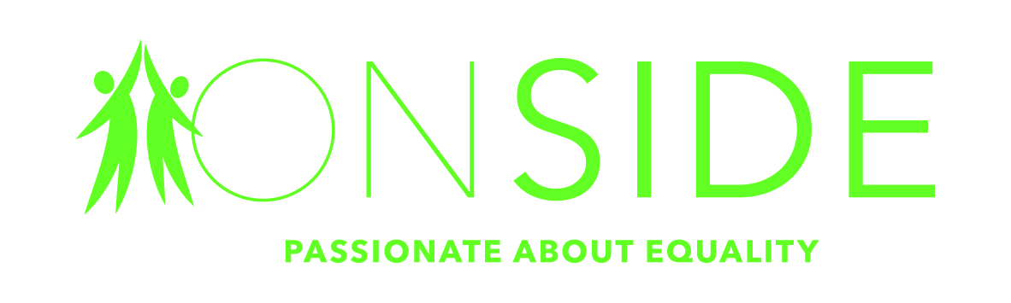

Community Mental Health Link Worker
Salary £20,990 per annum (pro rata)
30 Hours per week.
Worcester City Primary Care Network
26 days (pro rata) annual holiday + Bank Holidays + additional discretionary leave
Employee Assistance Programme
Onside & NHS Training & Personal Development Opportunities

Are you determined to make a difference, looking for a new challenge, and enjoy working in a dynamic and fast paced environment?

ONSIDE is an independent charity promoting the rights and interests of people facing disadvantage. No matter who you are or where you’re from, ONSIDE believes that everyone is entitled to fair, equal treatment and opportunity. We are all about people; supporting and empowering them to make informed decisions and to live the very best life possible. It’s an ambitious goal, and the rewards can be lifechanging for those concerned. Our skilled staff and volunteers make a real difference to the lives of over 8,500 people a year across Worcestershire and Herefordshire.
Our Community Mental Health Link Worker will be an exceptional individual who will work directly with patients to support their needs relating to social factors, wellbeing and wider determinants of health and be instrumental in enabling patients to link up all elements of their treatment and support.
Who are we looking for?
More people need our help than ever before. Because of that, we are growing faster than ever before. The role of Community Mental Health Link Worker is a real career opportunity to contribute to breaking down barriers for patients moving between primary and secondary mental health services and aims to embed a more joined up approach to patient care.

We are looking for someone who has experience of working positively with individuals with mental ill health and with an understanding of the impact poor mental health can have on a person’s life and the complex social and emotional challenges they may face.
Someone like you?

If you believe we should embrace difference and champion diversity.

If you are creative in your approach, can think around problems and find new ways to solve them

If you’re looking for a job that you can be proud of, and passionate about.
Please get in touch with us.

These values run through our entire organisation. ONSIDE is a creative, collaborative community where people feel free to share new ideas or ask for support. If something’s not right, we don’t just change it. We change ourselves too.

Closing Date for applications midday Monday 6th December 2021

Interviews will take place week commencing 13th December, in person

Contact Elly Munslow Tel 01905 27525 / email: recruitment@onside-advocacy.org.uk
Need more details about the role or about us? Visit www.onside-advocacy.org.uk/recruitment.

We’re also happy to have a short informal chat so you can discover if this is the right role for you. Get in touch with Jennie Reeves jennie.reeves@onside-advocacy.org.uk

