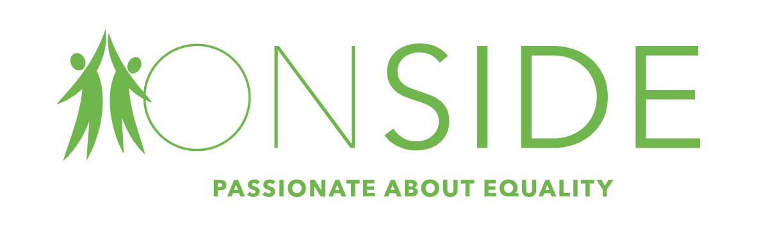
Onside is a voluntary organisation promoting the rights and interests of people facing disadvantage. We are all about people, supporting and empowering them to live the very best life possible. Onside works to strengthen communities and reduce loneliness, we ensure that the most vulnerable people are not alone and feel connected to the people and places closest to where they live.

We have an opportunity available within Worcestershire
Statutory Advocate
1 part time post (30 hours per week – must include a Friday)
Salary £19,000 - £23,000 per annum (pro rata)
Onside’s Statutory Advocacy services are well established within Worcestershire and cover the full range of advocacy service provision for the county. An opportunity has arisen to join our amazing team in providing advocacy services to support those who are most vulnerable in our community.

It is essential to have an open-minded, non-judgemental, respectful attitude together with an ability to easily create partnerships based on trust. Honesty and reliability are fundamental alongside a warm, friendly personality. It is important to be able to understand the needs and wishes of the individual and support them in ensuring their rights and interests are represented and their voice is heard.

You will need to be resourceful and creative. The work is challenging and rewarding and will involve working in many different locations. You will be required to travel across the county of Worcestershire extensively including isolated rural areas therefore the ability and means to travel independently are essential. There may also be a requirement for occasional cover in Herefordshire.

The Role
You will provide independent direct advocacy support to adults who are vulnerable or face disadvantage, ensuring their rights are respected and upheld; they have a voice in decision making processes and have access to the right services, support and advice. The support should be delivered in a way that is person centred, ensuring as far as possible, the person has as much participation within their own lives as possible and is sensitive to and respectful of diversity. The role of a statutory advocate is supported by legislation including The Care Act 2015, The Mental Health Act 2007 and The Mental Capacity Act 2005 so a working knowledge of these would be advantageous but not essential.

You should have experience of working as an advocate or in an advocacy related role as well as experience of working with adults and / or children with multiple, complex needs including non verbal communication.
Previous experience, qualifications and/or knowledge of statutory advocacy services are advantageous but not essential as training will be provided.

Closing Date for Applications: Wednesday 3rd June 2020

Interviews: via video meeting w/c 8th June 2020

For an application pack or specific queries regarding the posts please contact:
Emma Powell 01905 27525 or email: recruitment@onside-advocacy.org.uk

