Data Protection & Consent

What information do you hold about me?
In order for us to provide you with a service we need to record some of your personal information. This can include:
- Your name  - Your address  - Your telephone numbers  - Your email address  - Your date of birth | - Your ethnicity  - Any vulnerability  - Your nearest relative (IMHA only)  If you are paying for a service:  - Your bank details
What we do with your information and who we share it with:
- This information remains confidential and will only be shared with those directly involved in your support.
- We may also use general statistical information about you that has been anonymised in order to report back to the funders of the service and for internal monitoring purposes.
- We will not disclose your information to any other third parties without your permission unless there is a legal requirement to share the information, or there is a safeguarding concern for which we are required by law to share information with the relevant Local Authority (this can be without your consent), however, we will always endeavour to inform you beforehand.
How long we hold your information:
- Your information will be held securely for 7 years as required by contract, after which, it will be safely destroyed.
- During this time you have the right to request a copy, of any personal information we hold about you. Should you wish to do this please ask our administration team for further information.
Feedback:
To ensure that you were happy with the service you received and to help improve our services we will contact you at the end of your support and ask you to complete a short survey, how would you like to be contacted? Please select:

Choose an item.
Onside ensures that they will comply with all legislation relating to the collection and retention of data including but not limited to the Data Protection Act 1998

Our guiding principle is that we are holding your records in strictest confidence.

You may withdraw your consent at any time, for further information please contact our administration department.

Consent Section

☐ Yes I consent to Onside storing and using the personal information I have provided as detailed above

Signature:
Date:

If you are completing this form for a 3rd party or providing anyone else’s personal information please ensure you have their authority to share their information.

☐ Yes I have permission to give Onside the information I have provided
☐ No, please give reasons why:

PLEASE BE AWARE THAT WE MAY NOT BE ABLE TO PROCEED WITH THE REFERRAL IF YOU DO NOT HAVE AUTHORITY TO PROVIDE THE INFORMATION

Signature:
Date:

**PLEASE NOTE: All sections on this form must be completed. Forms will be returned if incomplete, and this may delay support being arranged**
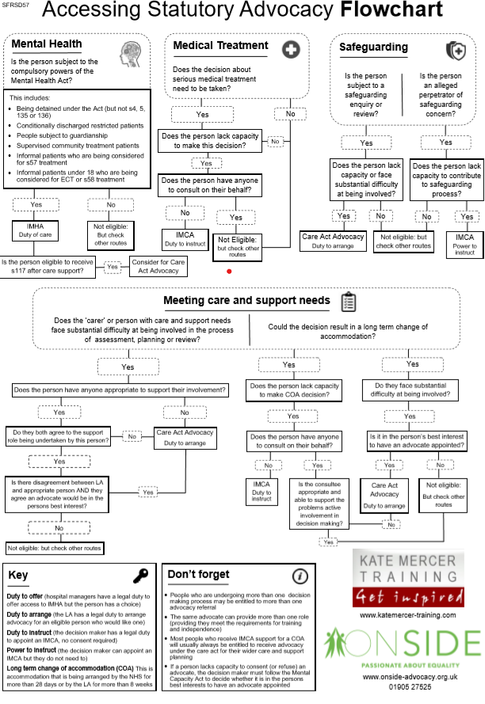
Care Act Referral Form

(Office use only) Referral taken by: Choose an item. | Date of Referral: Tap or click to add a date.

Service user details:
Name: |  | Gender: Choose an item.
Address (including postcode):

Date of Birth:

Telephone:  Can we leave message? Choose an item. | Mobile:  Can we leave message? Choose an item.
Email: | Residential Status: Choose an item.
Preferred Method of Contact: Choose an item. | Fluency in English: Choose an item.
Main Vulnerability: Choose an item. | Ethnicity? Choose an item.
Preferred place to meet?

Referrers Details:
Name of Referrer: |  | Relationship to person:
Address of Referrer:

Team Name: |  | Team Manager:
Telephone Number: |  | Mobile Contact Number:
Email Address:

Referral source: Choose an item.
Care Act Eligibility:
Who is the referral for: Choose an item.

Care Act Referral Category: Choose an item.

The person has substantial difficulty to:
(At least one category in the following list must apply to be eligible for a Care Act Advocate)

- Understanding relevant information Choose an item.
- Difficulty Retaining Information Choose an item.
- Difficulty using or weighing up information Choose an item.
- Difficult in communicating their views, wishes and feelings Choose an item.
AND:

There is no appropriate person to support:
(At least one category in the following list must apply to be eligible for a Care Act Advocate)

- No-one willing and able Choose an item.
- The person does not agree to be supported by the identified appropriate individual Choose an item.
- Not in a paid capacity Choose an item.

Does the person have capacity regarding the issue you are referring for? Choose an item.

Dates of any meetings already arranged:

Main vulnerability:
Herefordshire/other: Choose an item. | Worcestershire: Choose an item.
Aims and expectations of support:
- What support do you expect the advocate to provide?

- Please provide any additional information you think we should be aware of:

- Do you receive support from anyone else? Choose an item.

If yes, how often does this happen?

Risk Management:
Emergency contact details:
Name: | Telephone number:
Relationship to person:

Medical/health information:
Does the person you are referring have any medical or health issues that it would be helpful for us to know about so we can work safely with them? Choose an item.

If yes, please provide further relevant details:

Further information:
Does this person have a history of violence or aggression? Choose an item.

If yes, please provide further relevant details:

If you work or your organisation work with the person that you are referring, do you have any additional precautions or protocols in place to manage risk and ensure the safety of yourself and the service user? Choose an item.

If yes, please provide details of precautions/protocols:

Please highlight (as appropriate) below to tell us about any risks there may be associated with working with this individual.
Choose an item

Please tell us why you have rated the level of risk by giving us as much information as is relevant to any potential risk:

**Please email completed forms to accesshub@onside-advocacy.org.uk**

